MyImpact Challenge: Government & Community
Activity 3
In this activity you will...
- Describe the powers and limitations of government as enumerated in Article 1, Section 8 of the Constitution and its limitations as discussed in the Bill of Rights.
- Explain the limitations of government-based solutions.
- Analyze potential causes of your selected MIC problem using the “5 Whys” technique.
- Describe the role the government or government organizations could play in solving your MIC problem.

When confronted with big issues, many people ask what the government should be doing to help. However, as we will see, America’s government also has many limitations to prevent it from infringing on the rights of the people.

In evaluating the best approach to your own project, it is important to think about the government's connection to the problem and whether engaging the government is part of the solution.

What Can the Federal Government Do?
Let’s start by looking at the powers that the American Founders granted to the federal government. The clearest list of these powers is in Article One, Section Eight of the Constitution.

Directions: As you read Article 1, Section 8 of the United States Constitution, highlight the key ideas or responsibilities of the federal government. Then rewrite each one in your own words.
Article 1, Section 8 | In your own words...
The Congress shall have power to lay and collect taxes, duties, imposts and excises, to pay the debts and provide for the common defense and general welfare of the United States; but all duties, imposts and excises shall be uniform throughout the United States;
To borrow money on the credit of the United States;
To regulate commerce with foreign nations, and among the several states, and with the Indian tribes;
To establish a uniform rule of naturalization, and uniform laws on the subject of bankruptcies throughout the United States;
To coin money, regulate the value thereof, and of foreign coin, and fix the standard of weights and measures;
To provide for the punishment of counterfeiting the securities and current coin of the United States;
…To constitute tribunals inferior to the Supreme Court;
To define and punish piracies and felonies committed on the high seas, and offenses against the law of nations;
To declare war, grant letters of marque and reprisal, and make rules concerning captures on land and water;
To raise and support armies, but no appropriation of money to that use shall be for a longer term than two years;
To provide and maintain a navy;
To make rules for the government and regulation of the land and naval forces;
To provide for calling forth the militia to execute the laws of the union, suppress insurrections and repel invasions;
To provide for organizing, arming, and disciplining, the militia, and for governing such part of them as may be employed in the service of the United States, reserving to the states respectively, the appointment of the officers, and the authority of training the militia according to the discipline prescribed by Congress;
…To make all laws which shall be necessary and proper for carrying into execution the foregoing powers, and all other powers vested by this Constitution in the government of the United States, or in any department or officer thereof.
How would you summarize the powers of the federal government? Do these seem like powers that would be useful in addressing challenges in your community? Why or why not?

The powers of the federal government...

Levels of Government
When considering the role of government in solving community problems, it is important to remember that the government has many layers. The government body most involved in your local issue is unlikely to be the federal government. State governments have more connection to local matters, but even they may not be the closest to your chosen problem.

Many of the most visible government functions are performed by local governments. Your county has its own government, and you’ll have a local council if you live in an incorporated town, city, township, or village. Most policy decisions about your school will be made by your local school district, which may or may not line up with your county or city lines. There may also be governments you’re not familiar with that impact your day to day life. For instance, you may live in a water or utility district with it’s own authorities, and some big cities have elected neighborhood councils.

In addition to governments being divided into federal, state and local spheres, most governments at all levels have specialized offices and departments. For instance, most governments have specific departments to handle issues like public transportation, policing, or parks.

What part of the government do you think is closest to your chosen problem?

I think that the closest government to my problem is...

How Do I Find the Root Cause of a Problem?
But before you can present solutions to the challenges in your community, you need to have a deeper understanding of your problem so you can be sure you are addressing the root cause(s), and not just a symptom of a larger problem.

Root causes of a problem are those that can be clearly identified, fixed with proper management, and prevented through effective recommendations. The best way to dig deeper into your problem is to perform a Root Cause Analysis (RCA) which is a cool tool that helps you identify and solve problems.

We are going to perform a version of the RCA process called the ”5 Whys Analysis”. As the name implies, you’ll ask 'why' five times in order to get down to the root cause of your identified problem. The “whys” for each problem will vary depending on the problem, so we can’t provide you with your specific questions.
Let’s practice the “5 Whys Analysis.” You will work through each step of how to perform the analysis and record your findings in the graphic organizer below.

Directions: Use the following scenario to practice the “5 Whys Analysis.” You will go through multiple steps to get to the bottom of the problem below. There will be links throughout to bring you back to the scenario if you need a reminder.
Scenario: You are the mayor of a small town and are concerned that the attendance at this year’s town festival was much lower than in previous years. It takes a lot of money and effort to organize the festival, and you want to ensure that next year’s festival is a success.
Step 1: Identify the Problem | Define the problem clearly and succinctly. Aim for a phrase that is 5 words or fewer.
 | Write the problem here, then double click on the picture below to see the example.
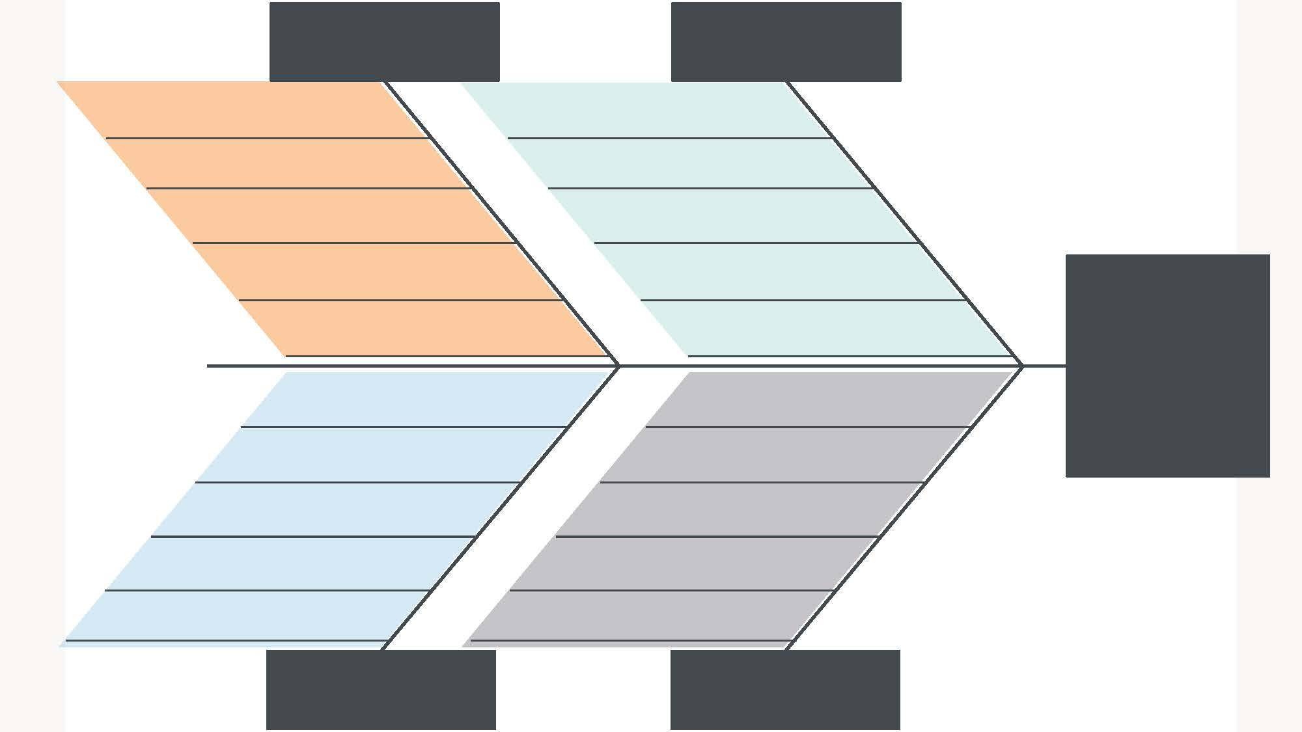
Poor attendance at the town festival
Move or delete this box to reveal the answer
Step 2: Identify Cause Categories | Identify at least four different cause categories that may be impacting the problem.  Ask yourself: What’s going on here? Is there a confusing procedure? Is there malfunctioning equipment? Is there an out-of-date policy? etc.
Let’s look at some of the common cause categories. Highlight four that best suit the problem in this scenario.

Methods  Materials  Machinery  People  Policies  Procedures | Plant  Measurement  Environment  Price  Promotion  Processes | Place  Product/Service  Surroundings  Suppliers  Systems  Skills

Now double click on the picture below to reveal the example.
Poor attendance at the town festival
Price
Procedures
People
Environment
Move or delete this box to reveal the answer
Move or delete this box to reveal the answer
Move or delete this box to reveal the answer
Move or delete this box to reveal the answer
Step 3: Ask they First Why | Think about the identified problem and ask yourself Why? the problem exists as it relates to the first category.  Why might there have been poor attendance as it relates to our first cause category, Price? Perhaps because this was the first year there was an admission fee for kids. Click here if you need to review the scenario.
Poor attendance at the town festival
Price
Procedures
People
Environment
Admission charged for kids
Step 4: Continue Asking Why | Next, ask your Why? regarding the first response within the category. Continue asking until you believe you’ve arrived at a root cause.  We determined that this year an admission fee was charged for kids. Now we ask, why was there an admission fee? Continue asking why until you feel like you’ve arrived at a possible root cause.  Click here if you need to review the scenario.
 | Focus on the Price category. Think of reasons why admission was charged. Record your answer below. Then double click on the picture to reveal the example.
 | Price:
Poor attendance at the town festival
Price
Procedures
People
Environment
Admission charged for kids
To cover additional costs
Equipment rental increased
Move or delete this box to reveal the example
Step 5: Ask Why for All Categories | Repeat Steps 3-4 for the remaining cause categories.  Why might there have been poor attendance as it relates to Procedures? Perhaps the festival was announced only two weeks in advance. Why?  Click here if you need to review the scenario.
 | Brainstorm some Whys for the remaining cause categories. Record your answer below, then double click on the picture to reveal the example.

Procedures:

People:

Environment:
Poor attendance at the town festival
Price
Procedures
People
Environment
Admission charged for kids
To cover additional costs
Equipment rental increased
Headlining band dropped out
Town noise policy
Band scheduled in late evening
Stage not free earlier
Location used for petting zoo
Announced only 2 weeks in advance
Move or delete this box to reveal the example
Advertising poster delayed
Employee on vacation
Limited parking
Festival Located downtown
Move or delete this box to reveal the example
Move or delete this box to reveal the example

How Do I Address the Root Cause?
Now that you have discovered the root causes of your problem, you can present potential solutions. You will make a list of all the ideas that emerged from the different possible root causes. The goal is to have a broader and more thorough list than we would have generated by thinking only about the initial problem.

Directions: Review the causes from the example scenario above. Brainstorm at least two possible solutions for each cause. Then consider how it relates to the role and limits of government organizations.
Cause | Possible Solutions | Does this fit within the role and limits of a government agency? Why or why not?
Procedures
Environment
Price
People
Describe how you might work with a government agency to solve one of the root causes in the town festival solution.

One way I might work with a government organization to solve...

My Next Project Component
Now it’s time to consider how your own MIC project problem might intersect with government organizations.

Identify the root causes of the problem you identified in Activity 1. You can always go back and refer to the example for guidance.

My Problem:

Root cause 1:

Root cause 2:

Root cause 3:

Root cause 4:

Now think about some possible solutions for the root causes of your problem. Try to think of at least two for each cause.
Cause | Possible Solutions | Does this solution intersect with a government organization?

Cause 1:
Cause 2:
Cause 3:
Cause 4:

How does the government or a government organization intersect with your problem or its root causes?

One way the government or a government organization intersects with my problem is...
How might a government agency be part of a solution that could address your problem?

One governmental solution that could address my problem is...
Who are the stakeholders, or interested parties, involved in this governmental solution?
These are the individuals who are
- closest to the problem,
- likely to have important knowledge about the situation, or
- able to take actions or make decisions to help solve the problem.

Some stakeholders are...
Of the stakeholders listed, who would be someone you would like to further interview to gain some more knowledge of your problem? Why this person?

Someone I would like to interview is.. because...
What are some questions you would ask this person?
What do you think would be required to implement this governmental solution, and how much effort do you think it would take to involve the government in this solution?

This solution would require...

What Do I Do Next?
Take a second look at the learning objectives at the start of this activity. Check off the objectives you feel you have successfully completed. Revisit the content or steps that you still have questions about. When you’re confident in your understanding of the objectives and the problem you have identified, continue to the next step.

